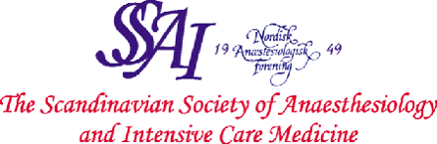

Application Form

7th Nordic Diploma Course in Advanced Pain Medicine
2014-2016

I hereby apply for the Nordic Educational Programme in Advanced Pain Medicine.

Name : ___________________________________________

Title and
Speciality : ___________________________________________

Address : ___________________________________________

___________________________________________

___________________________________________

Country : ___________________________________________

E-mail : ___________________________________________

All expenses for the programme (fee for the 5 courses, travel, accommodation and clinical training) will be covered by my host clinic or by me personally.

Final date for receiving the application: April 15th, 2014.

Date and signature of the applicant (scanned)

Date and signature of the chairman of the host clinic (scanned)

